WellBot – Global Wellness Assistant Chatbot
Day 1
WellBot is an intelligent, conversational assistant designed to help users explore and understand wellness-related data in an interactive and user-friendly way. Wellness chatbots are AI-driven systems that engage users through natural conversation and provide personalized guidance, insights, recommendations, and answers based on the information they receive or are trained on. These virtual assistants are increasingly used in health and lifestyle contexts to support wellness education, habit formation, and informed decision-making by interpreting user inputs and responding with meaningful, context-aware answers.
In the WellBot project, users will be able to upload wellness or related datasets (such as health metrics, lifestyle data, or fitness records) directly through an easy-to-use interface. Once the data is uploaded, the chatbot will analyze it and allow users to interact by asking questions such as “What trends do you see here?” or “Explain the key patterns in this dataset.” WellBot will interpret the data and respond with clear, insightful explanations that help users make sense of complex information a critical feature in modern data-driven wellness solutions.
The frontend of the application will be developed using React, offering a dynamic interface where users can upload files, enter queries, and receive responses in real time. React’s component-based architecture ensures a smooth, responsive experience across devices. Meanwhile, the backend will be built using Python, which will handle the core logic of processing uploaded data, applying natural language understanding techniques, and generating appropriate responses for user queries. Python’s extensive ecosystem of AI and data processing libraries makes it ideal for building this core analytical engine. This architecture ensures that data handling, model interaction, and response generation remain efficient, reliable, and scalable.
WellBot represents a meaningful step toward making wellness insights more accessible through conversational AI. By combining robust data analysis with an intuitive chat interface, it empowers users to interact with data and extract actionable insights without needing deep technical knowledge. This project not only enhances user engagement with wellness data but also demonstrates the potential of AI chatbots to transform how people understand and interact with personalized health information.

Day 2 – Team Formation & GitHub Repository Setup
On Day 2 of the internship, the mentor organized the project teams and assigned a team representative for each group to coordinate activities and ensure smooth collaboration. The responsibilities of the team representative include communicating with team members, monitoring progress, and managing the overall project workflow.
The mentor then introduced the importance of GitHub as a version control and collaboration platform. Students were instructed to create two separate repositories: one team repository for collaborative project development and one personal repository to maintain individual practice work, experiments, and learning artifacts. This approach helps track both team contributions and personal growth throughout the internship.
While creating repositories, the mentor explained essential components:
- README.md File: Used to describe the project, objectives, features, technologies used, and setup instructions.
- .gitignore File: Used to specify files and folders that should not be pushed to GitHub (such as environment files, cache files, or dependencies).
- MIT License: A permissive open-source license that allows others to freely use, modify, and distribute the project with proper attribution.
Students were guided on structuring repositories in a professional manner, committing code regularly, and writing meaningful commit messages. The session emphasized best practices for collaboration, code organization, and documentation.

Day 3-Git Commands & Python Virtual Environment

Basic Git commands for version control and how to create and manage a Python virtual environment to isolate project dependencies.
Git: A distributed version control system that tracks code changes and manages project history.
GitHub: A cloud platform for hosting Git repositories
GitLab: provides CI/CD, planning, and deployment tools.
Git add . → To adds all modified files.
Git add app.py →To adds only app.py file to staging area.
Git commit -m "message" → Saves staged changes with a message.
Git push → Uploads local commits to remote repository.
Git pull → Downloads and merges remote changes.
Git branch → Shows all local branches.
Git branch --all → Shows local and remote branches.
Git fetch --all → Fetches updates from all remotes without merging.
Git stash → Temporarily saves uncommitted changes.
Git checkout -b newbranchname → Creates and switches to new branch.
Git checkout branchname → Switches to an existing branch.
Python Virtual Environment
python -m venv venv → Creates virtual environment named venv.
python -m venv shakthi → Creates virtual environment named shakthi.
shakthi/Scripts/activate → Activates the virtual environment.
deactivate → Deactivates the virtual environment.

Day 4 – Software Development Life Cycle (SDLC) & Organizational Roles

1. Software Development Life Cycle (SDLC)
Software Development Life Cycle (SDLC) is a structured process followed to design, develop, test, and deploy a software system in a systematic way to ensure high quality and correct functionality.
SDLC helps organizations build software efficiently by dividing the development process into well-defined phases.

🔹 Common SDLC Phases
- Requirement Gathering
- Planning
- Design
- Development
- Testing
- Deployment
- Maintenance

2. Functional Consultant / Business Analyst (BA)
The Functional Consultant or Business Analyst acts as a bridge between the client and the technical team.

Responsibilities:
- Understand client business requirements
- Interact with client stakeholders
- Analyze problems and business workflows
- Convert business needs into functional requirements

Key Output:
Functional Specification Document (FSD)
FSD – Functional Specification Document
This document describes what the system should do, including features, workflows, inputs, outputs, and business rules.

3. Developer / Programmer
The Developer is responsible for building the application based on the functional specifications.

Responsibilities:
- Write application code
- Implement business logic
- Create database connections
- Build frontend and backend modules
- Create Proof of Concept (POC)

POC (Proof of Concept)
A small working model shown to the client to validate feasibility and approach.

Unit Testing
Unit Testing is single-level testing performed by developers to test individual modules or components of the application.

4. Tester / Quality Assurance (QA) Team
The QA team ensures the application works correctly and meets quality standards.

Responsibilities:
- Perform multiple rounds of testing
- Identify bugs and defects
- Verify functionality against requirements
- Ensure stability before production

5. Server Environments

Development Server
- Used by developers
- Code development and unit testing happen here

Quality Server (QA Server)
- Used by QA team
- Functional, integration, and regression testing

Production Server
- Live server used by end users
- Final approved application is deployed here

6. Administration Team
The Administration Team manages the complete IT infrastructure.

Responsibilities:
- Manage servers
- Manage databases
- Provide system access
- Monitor performance
- Handle security and backups
- Communicate with management and client regarding infrastructure

7. Product Manager / Project Manager
Acts as the middle person between client and development team.

Responsibilities:
- Collect project requirements
- Plan project timeline
- Assign tasks
- Track progress
- Ensure project delivery on time
- Manage risks

8. Sales and Marketing Team

Sales Team
- Estimate project budget
- Negotiate pricing
- Finalize contracts

Marketing Team
- Promote product/project
- Reach new markets
- Build company brand
- Attract potential clients

9. Human Resources (HR) Department

Responsibilities:
- Hiring employees
- Conduct interviews
- Manage employee records
- Payroll processing
- Handle employee concerns

10. Documentation Team
Creates and maintains all project-related documents.

Types of Documentation:
- User Manual
- Technical Document
- Functional Document
- Test Reports
- Project Reports

11. Support Team
Provides assistance to all departments.

Responsibilities:
- Coordinate between teams
- Handle operational issues
- Temporarily support other teams when required
- Ensure smooth workflow

12. Important Documents in SDLC

FSD – Functional Specification Document
Describes what the system should do.

TSD – Technical Specification Document
Describes how the system will be built.

QA Document
Contains test cases, test plans, and test results

Waterfall Model

1. Definition
The Waterfall Model is a traditional SDLC model where development progresses step by step in a fixed sequence. Each phase must be completed before moving to the next phase. Once a phase is finished, changes are difficult to make.
It is called “Waterfall” because progress flows downward like a waterfall.

2. Phases of Waterfall Model

1) Requirement Gathering
- Collect detailed requirements from client
- Understand business needs
- Document everything clearly
Output:
Software Requirement Specification (SRS) / Functional Specification Document (FSD)

2) System Design
- Design system architecture
- Decide technologies
- Database design
- UI design
Output:
Technical Specification Document (TSD)

3) Implementation (Development)
- Developers write code
- Frontend and backend development
- Database integration
Output:
Working source code

4) Testing
- Unit Testing
- Integration Testing
- System Testing
- Bug fixing
Output:
Test reports

5) Deployment
- Application installed on production server
- Users start using system

6) Maintenance
- Bug fixing
- Performance improvement
- Feature updates

3. Characteristics of Waterfall Model
- Linear and sequential
- No overlapping phases
- Documentation-heavy
- Easy to understand

4. Advantages of Waterfall Model
- Simple and easy to manage
- Clear milestones
- Well-documented
- Suitable for small projects

5. Disadvantages of Waterfall Model
- Changes are hard to implement
- Late testing
- High risk if requirements change
- Not suitable for complex projects

6. When to Use Waterfall
- Requirements are fixed
- Small projects
- Stable environment

Agile Methodology

1. Definition
Agile is an iterative and incremental development methodology where software is built in small parts called iterations or sprints. Continuous feedback and changes are welcomed.

2. Agile Life Cycle

1) Requirement Backlog
- Create list of features (Product Backlog)
- Prioritize tasks

2) Sprint Planning
- Select tasks for current sprint
- Define sprint goals

3) Sprint Execution (Development + Testing)
- Developers write code
- Testers test simultaneously
- Daily stand-up meetings

4) Sprint Review
- Demonstrate completed work
- Get client feedback

5) Sprint Retrospective
- Discuss what went well
- Discuss improvements

6) Release
- Deploy working features

3. Characteristics of Agile
- Iterative development
- Continuous feedback
- Flexible to changes
- Customer collaboration

4. Advantages of Agile
- Fast delivery
- Easy to handle changes
- Better customer satisfaction
- Early bug detection

5. Disadvantages of Agile
- Requires experienced team
- Difficult to estimate cost early
- Less documentation

6. When to Use Agile
- Requirements change frequently
- Large and complex projects

Client–Server Architecture & Security

DAY 5

1. Client–Server Architecture
Client–Server Architecture is a model where the client sends requests and the server processes them and returns responses.

Components:
Client
- Frontend interface (React application)
- Sends requests to the backend
- Example: User uploads a report or asks a question
Server
- Backend processing system (Flask)
- Handles logic, APIs, and AI processing
- Sends response back to client
Database
- Stores application data permanently
- Example: User details, reports, recovery plans

🔹 2. Workflow of Client–Server System
- User performs an action on frontend
- Client sends HTTP request (API call)
- Server processes request
- Server interacts with database if needed
Server sends response back to client
- Frontend displays result to user

3. Authentication
Authentication verifies the identity of the user.
Example
- Login using email/password
- Google Sign-In
- JWT token verification
Purpose:
- Ensures only valid users access the system.
4. Authorization
Authorization determines what a user is allowed to do.
Example:
- User can view only their own reports
- Admin may access all data
Purpose:
- Controls access permissions.

🔹 5. JWT (JSON Web Token)
JWT is used for secure authentication between client and server.

Why JWT?
- Stateless authentication
- Secure data transmission
- Used in REST APIs

JWT Flow:
- User logs in
- Server generates token
- Client stores token
- Token sent with every request

6. Database Design Concept
Database design is the structured organization of data into tables.
Example Table:
- User Table stores:
  - ID
  - Username
  - Email
  - Password (hashed)

SQL Keywords & Operators
DAY-6

1. SQL Overview
SQL (Structured Query Language) is used to manage and manipulate relational databases.
Functions:
- Store data
- Retrieve data
- Modify records
- Delete records

2. SQL Keywords

DISTINCT
Removes duplicate records.
SELECT DISTINCT column_name FROM table_name;

WHERE
Filters records based on condition.
SELECT * FROM users WHERE age > 20;
3. SQL Comparison Operators
Operator | Meaning
#ERROR! | Equal
!= or <> | Not equal
< | Less than
> | Greater than
<= | Less than or equal
>= | Greater than or equal
Example:
SELECT * FROM users WHERE age >= 18;

4. Logical Operators

AND
Both conditions must be true.
SELECT * FROM users WHERE age > 20 AND city = 'Hyderabad';

OR
At least one condition must be true.
SELECT * FROM users WHERE city = 'Delhi' OR city = 'Mumbai';

NOT
Negates a condition.
SELECT * FROM users WHERE NOT age = 25;

🔹 5. IN Operator
Matches multiple possible values.
SELECT * FROM users WHERE city IN ('Delhi','Chennai','Hyderabad');

🔹 6. BETWEEN Operator
Checks value within a range.
SELECT * FROM users WHERE age BETWEEN 18 AND 25;

🔹 7. LIKE Operator (Pattern Matching)
Used to search based on patterns.
Pattern | Meaning
A%' | Starts with A
%a' | Ends with a
%a%' | Contains a
Example:
SELECT * FROM users WHERE name LIKE 'S%';

8. IS NULL
Checks for missing values.
SELECT * FROM users WHERE phone IS NULL;

Day 7 – SQL & JWT

SQL (Structured Query Language)
SQL is used to create, store, retrieve, update, and delete data in a database.

Basic Database Operations
- Create a database
- Insert data
- Read data
- Update data
- Delete data
SQL Commands

1️. SELECT
Used to read data from a table.
SELECT * FROM tablename;

2️. INSERT
Used to insert data into a table.
INSERT INTO tablename VALUES (1, "harika", 20);

3️. UPDATE
Used to modify existing data.
UPDATE tablename SET age = 21 WHERE id = 1;

4️. DELETE
Used to delete records.
DELETE FROM tablename WHERE id = 1;

5️. CREATE
Used to create database or table.
CREATE TABLE students (id INT, name VARCHAR(50), age INT);

6️. ALTER
Used to modify table structure.
ALTER TABLE students ADD email VARCHAR(100);

7. DROP
Deletes table or database permanently.
DROP TABLE students;

8. RENAME
Rename a table.
RENAME TABLE students TO learners;

9️.TRUNCATE
Deletes all records but keeps table structure.
TRUNCATE TABLE students;
SQL Clauses

DISTINCT
Removes duplicate values.
SELECT DISTINCT age FROM students;

WHERE
Filters records based on condition.
SELECT * FROM students WHERE age > 18;

SQL Operators

Operator | Description
!= or <> | Not equal
< | Less than
> | Greater than
<= | Less than or equal
>= | Greater than or equal
AND | Both conditions true
OR | Any condition true
NOT | Negates condition
IN | Match multiple values
BETWEEN | Range check
LIKE | Pattern match
IS NULL | Check empty values

LIKE Pattern Examples
Pattern | Meaning
a% | Starts with a
%a | Ends with a
%a% | Contains a
A_ | A + one character
A%o | Starts with A and ends with o
SELECT * FROM students WHERE name LIKE 's%';

Aggregate Functions
Function | Purpose
MIN() | Smallest value
MAX() | Largest value
COUNT() | Total records
AVG() | Average value
SELECT COUNT(*) FROM students;

SQL Joins

INNER JOIN
Returns only matching records.
SELECT * FROM A INNER JOIN B ON A.id = B.id;

LEFT JOIN
All records from left table + matching from right.
SELECT * FROM A LEFT JOIN B ON A.id = B.id;

RIGHT JOIN
All records from right table + matching from left.
SELECT * FROM A RIGHT JOIN B ON A.id = B.id;

CROSS JOIN
All possible combinations.
SELECT * FROM A CROSS JOIN B;

UNION Operations

UNION
Combines results without duplicates.
SELECT name FROM A
UNION
SELECT name FROM B;

UNION ALL
Combines results with duplicates.
SELECT name FROM A
UNION ALL
SELECT name FROM B;

INTERSECT
Common records.
SELECT name FROM A
INTERSECT
SELECT name FROM B;

EXCEPT
Records not in second table.
SELECT name FROM A
EXCEPT
SELECT name FROM B;

JWT (JSON Web Token)
JWT is used for secure authentication and authorization.

Installation
pip install pyjwt

JWT Example (Python)
import jwt
import datetime
SECRET_KEY = "mysecretkey"
payload = {
"user_id": 101,
"username": "shakthi",
"exp": datetime.datetime.utcnow() + datetime.timedelta(minutes=30)
}
token = jwt.encode(payload, SECRET_KEY, algorithm="HS256")
print(token)

Why JWT?
- Stateless authentication
- Secure token-based access
- Used in APIs and web applications

Day 8 – Python Basics

Topic: Sets, Methods & Dictionaries

Sets in Python

Definition
A set is an unordered collection of unique elements.
- No duplicate values
- No indexing
- Mutable (can add/remove items)
Creating a Set
numbers = {1, 2, 3, 4}
print(numbers)
OR
numbers = set([1, 2, 3, 3])
print(numbers) # Output: {1, 2, 3}
Important Properties
- Unordered
- No duplicates
- Cannot contain mutable types like lists

Set Methods
Method | Description
add() | Adds an element
remove() | Removes element (error if not found)
discard() | Removes element (no error)
pop() | Removes random element
clear() | Removes all elements
union() | Combines two sets
intersection() | Common elements
difference() | Elements in first but not in second
issubset() | Checks subset

Examples
A = {1, 2, 3}
B = {3, 4, 5}
print(A.union(B)) # {1,2,3,4,5}
print(A.intersection(B)) # {3}
print(A.difference(B)) # {1,2}

Dictionary in Python

Definition
A dictionary stores data in key-value pairs.
Format:
{key: value}

Creating a Dictionary
student = {
"name": "Harika",
"age": 20,
"course": "CSE"
}
Accessing Values
print(student["name"])

Adding / Updating Values
student["age"] = 21
student["city"] = "Hyderabad"

Deleting Values
del student["city"]
Dictionary Methods
Method | Description
keys() | Returns all keys
values() | Returns all values
items() | Returns key-value pairs
get() | Returns value safely
pop() | Removes specific key
clear() | Removes all items
update() | Updates dictionary

Examples
print(student.keys())
print(student.values())
print(student.items())
print(student.get("name"))
student.pop("age")
student.update({"age": 22})

Difference Between List, Set & Dictionary

Feature | List | Set | Dictionary
Ordered | Yes | No | Yes (Python 3.7+)
Duplicates | Allowed | Not Allowed | Keys not allowed
Indexing | Yes | No | By Key
Format | [] | {} | {key:value}
DAY -9
Project Completion
Day 10
MileStone 1-presentaion
Day 11
Milestone 1-presentation
Day 12
Milestone 1-presentation

Day 13 – Python Advanced Built-in Functions & Concepts

File I/O Methods
File I/O (Input/Output) is used to read and write data to files.

Opening a File
file = open("sample.txt", "r")

Common File Methods:
Method | Description
open() | Opens a file
read() | Reads entire file content
readline() | Reads one line at a time
readlines() | Reads all lines as a list
write() | Writes data into file
writelines() | Writes multiple lines
close() | Closes the file

Example:
file = open("data.txt", "w")
file.write("Hello World")
file.close()

Common Built-in Functions
Function | Purpose
len() | Returns length
range() | Generates number sequence
print() | Displays output
type() | Returns datatype
id() | Returns memory address
sorted() | Returns sorted list
enumerate() | Returns index + value
zip() | Combines iterables

Example:
nums = [10, 20, 30]
print(len(nums))
print(sorted(nums))

Type Conversion Functions
Function | Purpose | Example
int() | Converts to integer | int("10") → 10
float() | Converts to decimal | float("5.5") → 5.5
str() | Converts to string | str(100) → "100"
list() | Converts to list | list((1,2,3))
dict() | Converts to dictionary | dict([(1,"a")])
set() | Converts to set | set([1,1,2])
tuple() | Converts to tuple | tuple([1,2,3])

Mathematical Functions
Function | Purpose | Example
abs() | Absolute value | abs(-10) → 10
sum() | Adds elements | sum([1,2,3]) → 6
min() | Smallest value | min(5,2,9)
max() | Largest value | max(5,2,9)
pow() | Power | pow(2,3) → 8

Class & Object Related Functions
Function | Purpose
getattr() | Get attribute value
setattr() | Set attribute value
hasattr() | Check attribute existence
delattr() | Delete attribute
isinstance() | Check object type
issubclass() | Check subclass relationship

Example:
class Person:
name = "John"
p = Person()
print(getattr(p, "name"))

Exception Handling
Used to handle runtime errors safely.

Keywords:
- try → Code that may cause error
- except → Handles error
- finally → Always executes

Example:
try:
x = 10/0
except:
print("Error occurred")
finally:
print("Done")

Memory & Object Management
Function | Purpose
del() | Deletes variable
gc.collect() | Garbage collection

Example:
import gc
del x
gc.collect()
Dynamic Code Execution
Function | Purpose
eval() | Executes single expression
exec() | Executes block of code

Example:
print(eval("10+5"))
exec("a=5\nb=6\nprint(a+b)")

Day 14 – AI Models & API Concepts

AI Model
Today we learned about major AI companies and their models.

Google → Gemini Models
- Developed by Google DeepMind
- Gemini models support text, image, and multimodal AI tasks
- Used for chatbots, reasoning, summarization, and coding
- Integrated into Google products and APIs
Example:
- Gemini Pro
- Gemini 1.5

OpenAI → GPT Models
- GPT = Generative Pre-trained Transformer
- Used for chat, coding, summarization, translation, and reasoning
- Examples:
  - GPT-4o
  - GPT-4o-mini
  - GPT-3.5

Groq → Ultra-Fast Inference Hardware + LLMs
- Groq provides high-speed AI inference hardware
- Optimized for running large language models quickly
- Focuses on performance and speed
- Used for real-time AI systems

Microsoft → Copilot & Azure OpenAI
- Microsoft integrates OpenAI models into:
  - Microsoft Copilot
  - Azure OpenAI Services
- Used in enterprise AI applications
- Secure cloud-based AI deployment

Rate Limit & Token Limit
Rate limit controls:
- How many requests you can send per minute/hour
- Prevents API overload
Example:
- 60 requests per minute
If exceeded → API returns error.
Token = Small unit of text (word pieces)
Example:
"Hello world" = 2–3 tokens
Token limit controls:
- Maximum input + output tokens allowed per request
Example:
- Model supports 128k tokens
- If you send too much text → request fails

Day 15 – Introduction to NLP & NLTK

Introduction to NLP
NLP (Natural Language Processing) is a branch of Artificial Intelligence that enables computers to understand, interpret, and generate human language.
It allows machines to:
- Understand text
- Analyze meaning
- Identify patterns
- Extract useful information

Applications of NLP
- Chatbots (like WellBot)
- Sentiment analysis
- Language translation
- Speech recognition
- Spam detection
- Named Entity Recognition
Steps in NLP Implementation

Step 1: Collecting the Data
Gather raw text data such as:
- Chat messages
- Medical reports
- Reviews
- Social media posts
Example:
text = "WellBot helps users analyze medical reports."

Step 2: Prepare and Engineer Features
Clean and transform data into structured format:
- Remove punctuation
- Convert to lowercase
- Remove stopwords
- Apply stemming or lemmatization
- Convert text into numerical form (like TF-IDF, embeddings)

NLTK (Natural Language Toolkit)
NLTK is a Python library used for:
- Text processing
- Tokenization
- Stopword removal
- Stemming
- Lemmatization
- POS tagging
- Named Entity Recognition (NER)

Key Steps in NLTK

1. Tokenization
Breaking text into words.
from nltk.tokenize import word_tokenize
text = "WellBot is an intelligent health assistant."
tokens = word_tokenize(text)
print(tokens)

Output:
['WellBot', 'is', 'an', 'intelligent', 'health', 'assistant', '.']

2. Stop Words Removal
Remove common words like "is", "an", "the".
from nltk.corpus import stopwords
stop_words = set(stopwords.words("english"))
filtered = [word for word in tokens if word.lower() not in stop_words]
print(filtered)

3. Stemming
Reduce word to root form.
from nltk.stem import PorterStemmer
stemmer = PorterStemmer()
words = ["running", "playing", "studies"]
stemmed = [stemmer.stem(word) for word in words]
print(stemmed)
Output:
['run', 'play', 'studi']

4. Lemmatization
Convert word to meaningful base form.
from nltk.stem import WordNetLemmatizer
lemmatizer = WordNetLemmatizer()
print(lemmatizer.lemmatize("wolves"))
Output:
wolf

5. POS Tagging (Part of Speech Tagging)
Identifies grammatical role of words.
import nltk
nltk.download('averaged_perceptron_tagger')
tokens = word_tokenize("WellBot analyzes medical reports")
print(nltk.pos_tag(tokens))
Example Output:
[('WellBot', 'NNP'), ('analyzes', 'VBZ'), ('medical', 'JJ'), ('reports', 'NNS')]

6. Named Entity Recognition (NER)
Identifies entities like names, locations, organizations.
import nltk
nltk.download('words')
nltk.download('maxent_ne_chunker')
from nltk import ne_chunk
sentence = "WHO provides global health guidelines."
tokens = word_tokenize(sentence)
pos_tags = nltk.pos_tag(tokens)
entities = ne_chunk(pos_tags)
print(entities)
NER detects:
- WHO → Organization
- Countries → GPE
- Person names → PERSON
Required Downloads for NLTK
import nltk
nltk.download('punkt')
nltk.download('stopwords')
nltk.download('wordnet')
nltk.download('words')
nltk.download('maxent_ne_chunker')

Day 16 – Machine Learning Basics

What is Machine Learning?
Machine Learning (ML) is a branch of Artificial Intelligence that enables computers to learn from data and make predictions without being explicitly programmed.
Instead of writing fixed rules, we train models using data.

Three Main Types of Machine Learning

1. Supervised Learning
- Uses labeled data (input + correct output)
- Model learns from examples
Example:
- Spam detection
- Disease prediction
Two main tasks:
- Regression
- Classification

2. Unsupervised Learning
- Uses unlabeled data
- Finds hidden patterns
Example:
- Customer segmentation
- Clustering similar documents
Main task:
- Clustering
3. Reinforcement Learning
- Learns by trial and error
- Receives rewards or penalties
Example:
- Game AI
- Robotics
- Self-driving systems
Regression
Regression predicts continuous values.
Example:
- Predict house price
- Predict temperature
- Predict health score
Classification
Classification predicts categories.
Example:
- Spam or Not Spam
- Disease or No Disease
- Yes or No
Clustering
Clustering groups similar data without labels.
Example:
- Grouping patients with similar symptoms
- Customer segmentation
Popular Algorithm:
- K-Means
Embedding
Embedding is the process of converting text or data into numerical vectors.
Machines understand only numbers.
Example:
"Headache" → [0.23, 0.78, 0.12, ...]
Used in:
- Chatbots
- Recommendation systems
- NLP models
Conversion of Text to Numbers (Vectorization)
Text must be converted into vectors before applying ML models.
Methods:
- Bag of Words
- TF-IDF
- Word Embeddings
Example using Scikit-learn:
from sklearn.feature_extraction.text import CountVectorizer
texts = ["I have headache", "I feel better"]
vectorizer = CountVectorizer()
X = vectorizer.fit_transform(texts)
print(X.toarray())

Logistic Regression

Definition
Logistic Regression is a supervised machine learning classification algorithm used to predict binary outcomes.
Examples:
- 0 or 1
- Yes or No
- True or False
Sigmoid Function
It converts output into probability between 0 and 1.
Formula:
Sigmoid(z) = 1 / (1 + e^(-z))

Final Prediction Rule
- If y ≥ 0.5 → Class = 1
- If y < 0.5 → Class = 0
Example using Scikit-learn
from sklearn.linear_model import LogisticRegression
from sklearn.datasets import load_iris
from sklearn.model_selection import train_test_split
data = load_iris()
X = data.data
y = data.target
# Binary classification (just first two classes)
X = X[y != 2]
y = y[y != 2]
X_train, X_test, y_train, y_test = train_test_split(X, y, test_size=0.2)
model = LogisticRegression()
model.fit(X_train, y_train)
print("Accuracy:", model.score(X_test, y_test))

Decision Tree

Definition
Decision Tree is a supervised learning algorithm used for classification and regression.
It splits data into branches based on conditions.
Example:
If fever → yes
If headache → yes
Else → no

Example
from sklearn.tree import DecisionTreeClassifier
from sklearn.datasets import load_iris
from sklearn.model_selection import train_test_split

data = load_iris()
X_train, X_test, y_train, y_test = train_test_split(data.data, data.target, test_size=0.2)
model = DecisionTreeClassifier()
model.fit(X_train, y_train)
print("Accuracy:", model.score(X_test, y_test))

What is Scikit-learn?
Scikit-learn (sklearn) is a Python library used for:
- Classification
- Regression
- Clustering
- Model evaluation
Install:
pip install scikit-learn
Import example:
from sklearn.linear_model import LogisticRegression
Day 17
Project Work
Day 18
Project Work

Day 19
Project Presentation
Day 20
Project Presentation
Day 21
Type of Learning
Supervised Learning
Used for Classification &amp; Regression
Not used for clustering (that’s K-Means)
Why KNN is Called a “Lazy Learner”
Unlike algorithms like:
Decision Tree
Logistic Regression
Support Vector Machine

KNN:
Does NOT build a model during training
No equation is formed
Stores the dataset
Does work only at prediction time
That’s why it’s called:
Lazy Learning Algorithm
Distance Metrics in KNN
1. Euclidean Distance
Formula:
Used when:
Data is continuous
Features are numerical2. Manhattan Distance

Used when:
Grid-like data
High dimensional data
3. Minkowski Distance
Generalized form:
p = 1 → Manhattan
p = 2 → Euclidean
Choosing the Right K Value
This is VERY important for exams.
If K is small (like 1):
Overfitting
Sensitive to noise
If K is large:
Underfitting
Less flexibleCommon trick:

Where N = total data points
Also use:
Cross Validation

Steps:
1. Calculate distance to all points
2. Sort distances
3. Choose K=3
4. Majority vote
Result = A (if 2 A are nearest)

Regression in KNN
Instead of majority vote:
�� Take average
Example:
Nearest values: 10, 12, 14
Prediction = (10+12+14)/3 = 12

Day 22

Topic: K-Means & K-Nearest Neighbors (KNN)
K-Means is an unsupervised learning algorithm used for clustering data into K groups based on similarity.
It groups similar data points together without using labeled output.
How K-Means Works
- Choose number of clusters (K)
- Randomly initialize centroids
- Assign points to nearest centroid
- Update centroids
- Repeat until centroids stabilize

Use Case
- Customer segmentation
- Grouping patients by symptoms
- Market analysis

K-Nearest Neighbors (KNN)
KNN is a supervised learning algorithm used for classification and regression.
It classifies a data point based on the majority class of its K nearest neighbors.

How KNN Works
- Choose value of K
- Calculate distance between new point and training data
- Select K nearest neighbors
- Majority voting decides the class
Example Use Case
- Disease prediction
- Spam detection
- Recommendation systems

Difference Between K-Means and KNN

Feature | K-Means | KNN
Type | Unsupervised | Supervised
Purpose | Clustering | Classification
Needs Labels | No | Yes
Example | Grouping customers | Predict disease

Day 23

Backpropagation

Backpropagation is not just an algorithm.
It is the intelligence correction mechanism of a neural network.
It answers one core question:
Which weight is responsible for how much of the mistake?
Without this, learning is blind.

Where It Is Used
- Artificial Neural Networks
- Multilayer Perceptron (MLP)
- Deep Neural Networks
- CNNs
- RNNs
Any model trained with gradient descent relies on it.

The Core Mechanism
Backpropagation has two directional flows:
- Forward flow of information
- Backward flow of responsibility

1️⃣ Forward Propagation
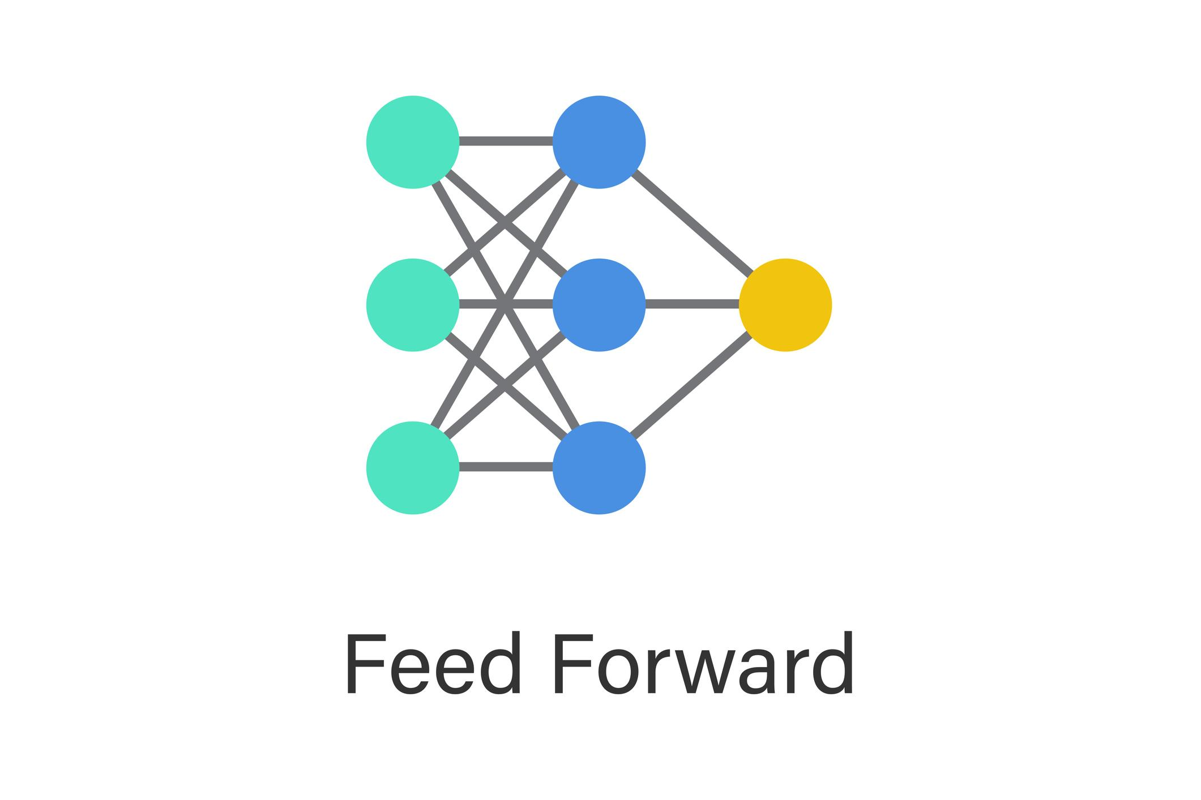

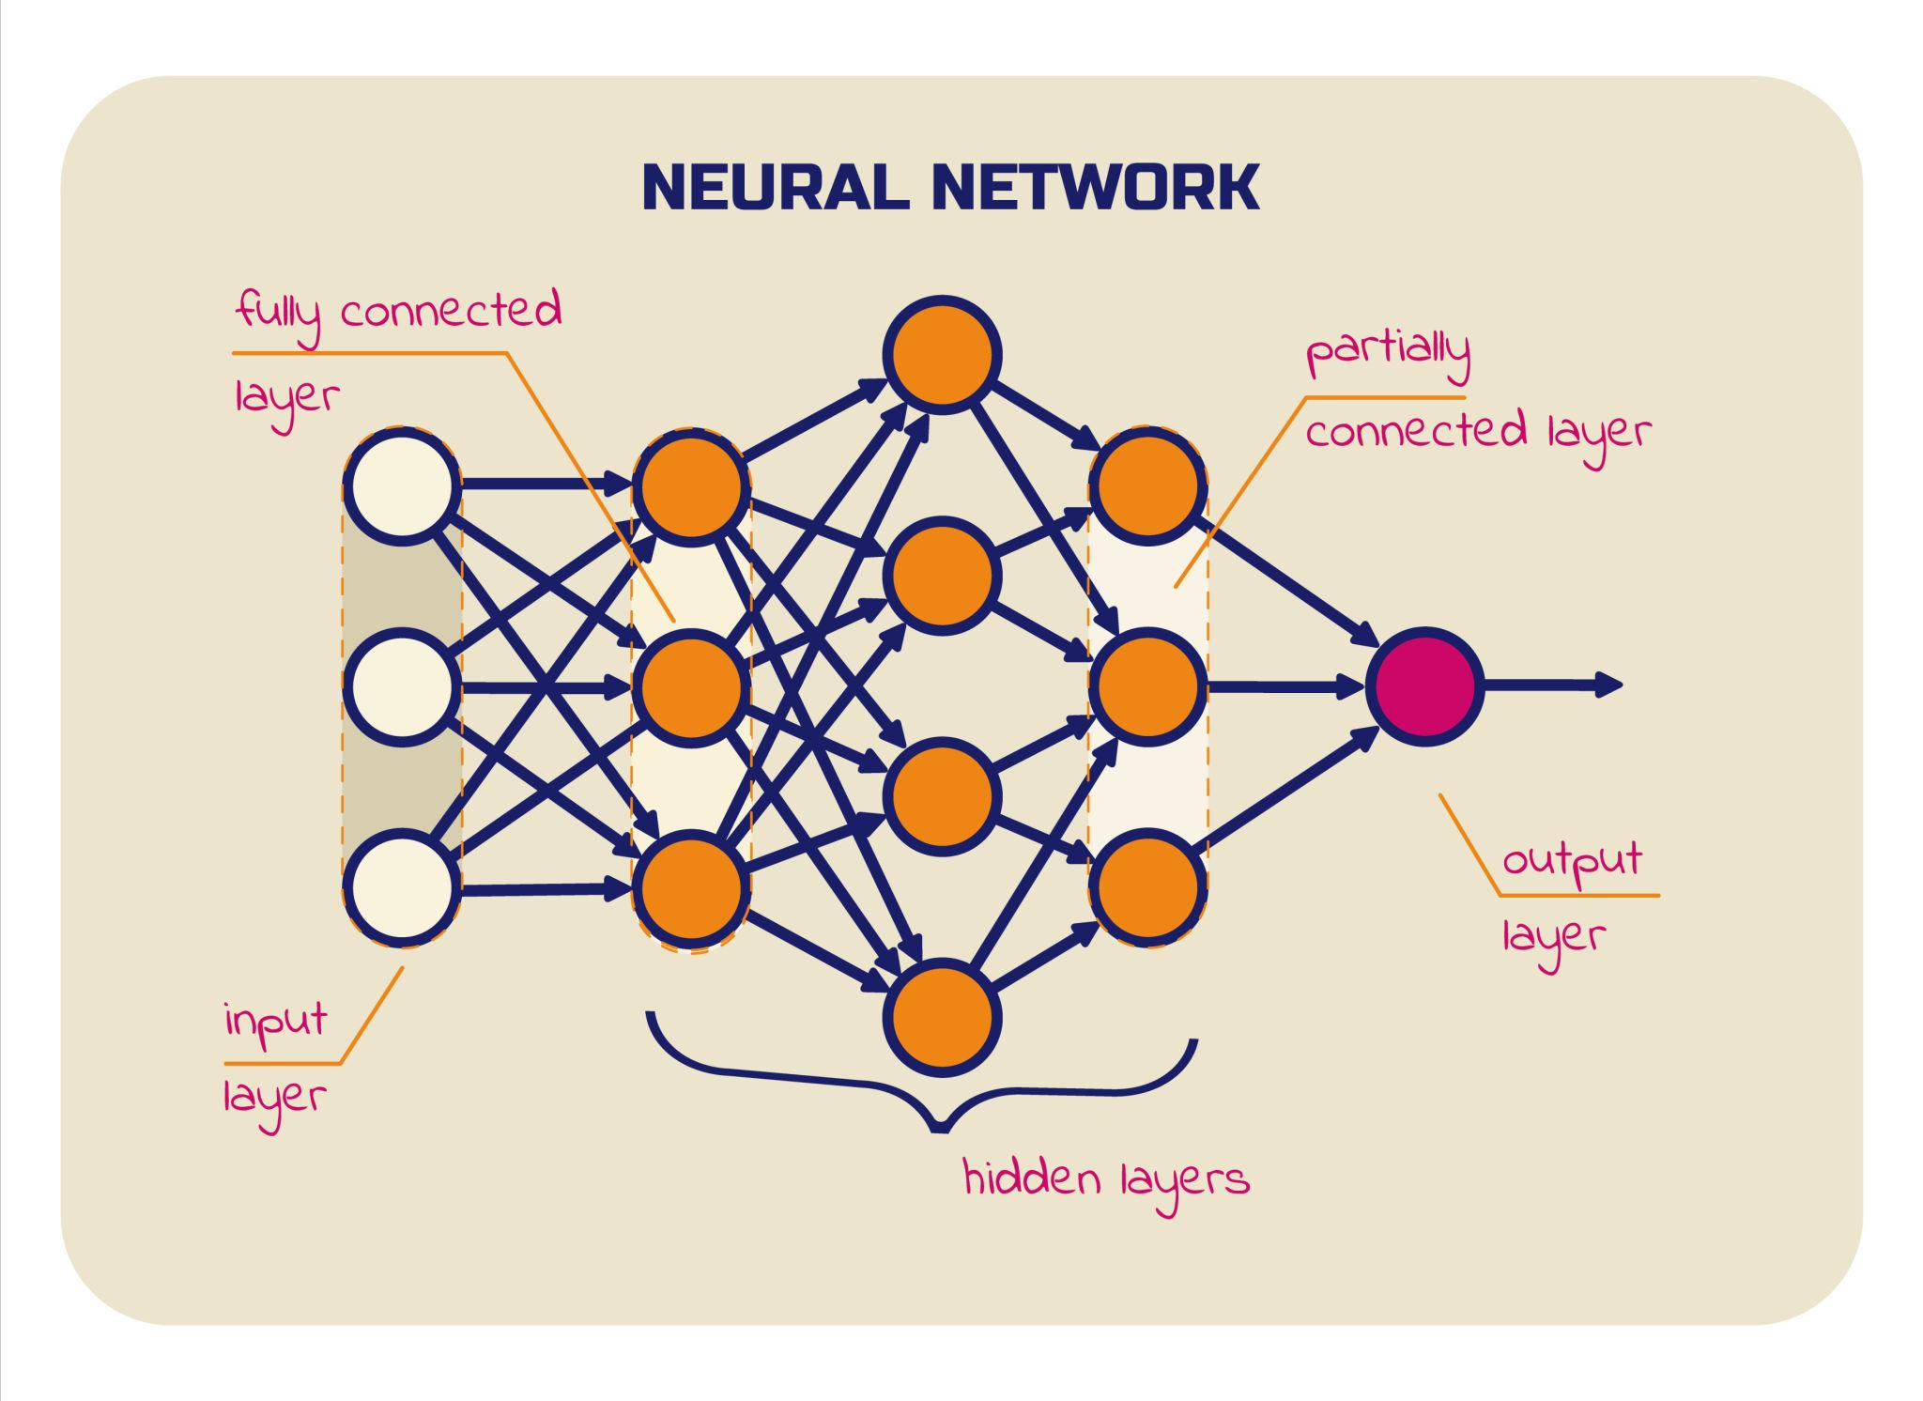
Flow:
Input → Weights → Activation → Output
Mathematically:
𝑧=𝑤𝑥+𝑏z=wx+b𝑎=𝑓(𝑧)a=f(z)
This produces the predicted output.

Error Calculation
Error=Actual−PredictedError=Actual−Predicted
Common loss functions:
- Mean Squared Error (MSE)
- Cross Entropy
Loss gives a numerical measure of wrongness.

Backward Propagation (The Core Intelligence)
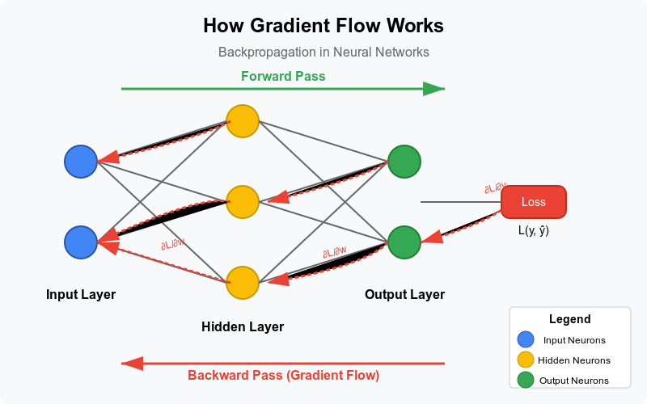

This breaks a complex network into small manageable derivatives.
This is how gradients move layer by layer from output → input.

Weight Update Rule
𝑤𝑛𝑒𝑤=𝑤𝑜𝑙𝑑−𝜂∂𝐿∂𝑤wnew​=wold​−η∂w∂L​
Where:
- η = Learning Rate
- ∂ = Partial derivative
This is Gradient Descent in action.

Simple Single Neuron Example
Given:
- x = 2
- w = 3
- y = wx = 6
- Actual = 10
Error = 4
If gradient = -8
Weight update:
𝑤𝑛𝑒𝑤=3−𝜂(−8)wnew​=3−η(−8)
If η = 0.1
𝑤𝑛𝑒𝑤=3+0.8=3.8wnew​=3+0.8=3.8
The weight increases → output increases → error reduces.
Learning happens.

Conceptual TensorFlow Example
import tensorflow as tf
model = tf.keras.Sequential([
tf.keras.layers.Dense(10, activation='relu'),
tf.keras.layers.Dense(1)
])

model.compile(optimizer='adam', loss='mse')
You never manually write backprop here.
The framework computes gradients automatically using automatic differentiation.

Exam-Level Key Points
✔ Backpropagation uses Chain Rule
✔ Works only with differentiable activation functions
✔ Updates weights to minimize loss
✔ Requires learning rate
✔ Core to deep learning

Strategic Insight
Backpropagation scales intelligence.
Instead of manually tuning thousands or millions of weights,
we let calculus distribute responsibility automatically.
That is the breakthrough.
Day 24 – Milestone 3 Topics
DAY 25- project development
DAY-26 project development

